|  |
| --- |
|  |
| BIFROST CoLLIMATION SLIT SYSTEM MOTION SAT |
|  |

|  | Name | Role/Title |
| --- | --- | --- |
| Owner | Anders Sandström | Electronics Engineer Motion Control & Automation |
| Reviewer | Thomas Gahl | Group Leader Motion Control & Automation |
| Approver | Liam Whitelegg | Instrument Lead Engineer for BIFROST |

TABLE OF CONTENT PAGE

1. Background 4

1.1. Equipment in scope 4

2. Requirements 4

3. CONTROL SYSTEM 4

3.1. Hardware 5

3.2. EL7037 Stepper drive 5

3.3. EL7201 Resolver interface 5

3.4. Feedback systems 5

3.4.1. Laser triangulation sensor Micro Epsilon ILD2300 5

3.4.2. Resolver, AMCI R11X-J10/N 5

4. METHOD 7

4.1. General Inspection 8

4.1.1. Mechanical 8

4.1.2. Electrical 8

4.2. Motion Tests 8

4.2.1. Initial Motion Test 8

4.2.2. Repeatability 9

4.2.3. Accuracy 9

4.2.4. Switch Performance 9

4.2.5. Resolver Performance 9

4.2.6. Data Acquisition 9

4.3. Presentation of results 10

4.1. Analysis 10

5. Results 11

5.1. 11358 Axis 1 11

5.2. 11358 Axis 2 12

5.3. 11359 Axis 1 14

5.4. 11359 Axis 2 16

5.5. 11360 Axis 1 17

5.6. 11360 Axis 2 18

5.7. 11361 Axis 1 19

5.1. 11361 Axis 2 20

6. CONCLUSIONS 21

7. references 22

8. Appendix A Micro Epsilon ILD2300 Calibration REPORT 23

list of tables

Table 1:Status 10

Table 2: Results 11358, axis 1 11

Table 4: Results 11358, axis 2 12

Table 5: Results 11359, axis 1 14

Table 6: Results 11359, axis 2 16

Table 7: Results 11360, axis 1 17

Table 8: Results 11360, axis 2 18

Table 9: Results 11361, axis 1 19

Table 10: Results 11361, axis 2 20

list of Figures

Figure 1: JJ X-RAY: Slit set 4

Figure 2: Test setup 7

Figure 3: Bent levers of limit switches 13

Figure 4: Bent limit switch lever 15

# Background

The ESS BIFROST instrument have acquired 3 slit sets form JJ X-RAY. One extra identical slit set was delivered to ESS MCAG group.

This document covers SAT of all 4 slit systems. The SAT is performed by ESS MCAG (Motion Control and Automation Group).

## Equipment in scope

Each JJ X-RAY slit set consists of two motorized translation stages. Each translation stage can be

individually positioned in the vertical direction, Figure 1.

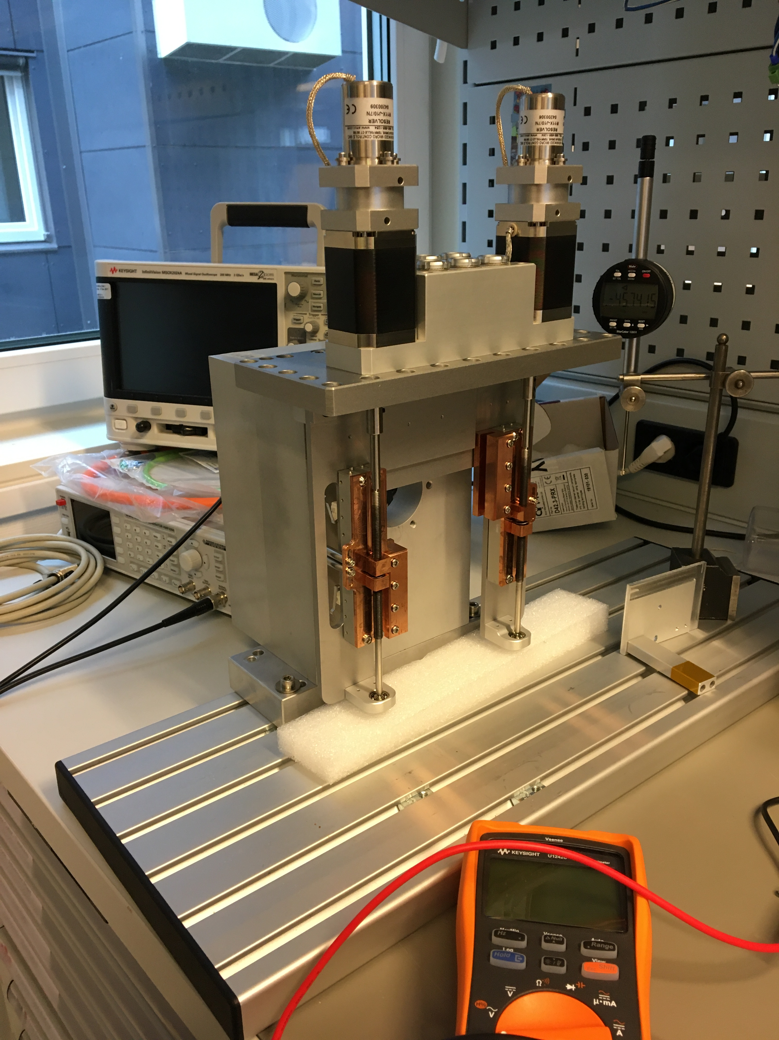

Figure 1: JJ X-RAY: Slit set

Each axis is equipped with the following components:

* Stepper motor: AML-D42.3 [8]
* Resolver: AMCI R11X-J10/N [10]
* Limit switches (fwd and bwd): Saia-Burgess F4T7YC-GP-UL
* Stroke: Approx. 70mm
* Leadscrew (1mm pitch)

# Requirements

The following requirements have been set by the BIFROST team:

1. Stroke: 40mm
2. Accuracy: +-0.1mm
3. Repeatability: +-0.05mm
4. Resolution: 0.01mm minimum

# CONTROL SYSTEM

The SAT was performed with an EtherCAT [1] based control system, ecmc [2]. The configuration files, raw data and analysis results for the SAT have been added to a git repository [3].

All hardware needed for the tests have been integrated into the same system which then leads to that all sampled data have the same time base.

## Hardware

The following control hardware was used:

1. EL7037: Stepper motor drive [4]
2. EL1808: Digital input for switches [5]
3. EL2808: Digital output to feed switches [6]
4. El7201: Resolver interface [7]
5. ILD2300: Micro Epsilon laser triangulation sensor [8].

## EL7037 Stepper drive

The EL7037 stepper drive was configured in a similar way as was done in the JJ X-RAY FAT procedure, [9]:

1. Control mode: Open loop
2. Run current: 0.61A
3. Standby current: 0.087A
4. Micro stepping: 64fold (resolution 12800steps/rev for the 200m step motor)
5. Velocity: 0.75mm/s (slower than the 2.5mm/s what JJX-RAY used at FAT)

## EL7201 Resolver interface

The EL7201 resolver interface delivers a single turn resolution of 20bits (1048576 counts/rev).

## Feedback systems

Two different sensors are used as position feedback for the tests.

1. ILD2300 : Micro Epsilon Laser triangulation sensor [9].
2. Resolver : AMCI R11X-J10/N [10]

### Laser triangulation sensor Micro Epsilon ILD2300

The Micro Epsilon ILD2300 sensor was used as external measurement and verification system. The ILD2300 have the following specs:

1. Range: 50mm
2. Linearity: +-10 μm (protocol: Appendix A Micro Epsilon ILD2300 Calibration)
3. Resolution: 0.8 μm

This sensor can only cover parts of the approximate 70mm stroke.

### Resolver, AMCI R11X-J10/N

The AMCI resolver was delivered with the slits mounted on the second shaft of the motor. The AMCI R11X-J10/N resolver have the following specs:

1. Accuracy: 7 arcmin (0.12deg)
2. Input voltage: 7V
3. Input frequency: 5000Hz
4. Transformation ratio: 0.95+-5%

The accuracy of 7arcmin corresponds to a linear accuracy of 0.32μm.

# METHOD

Each axis of the 4 slit sets, in total 8 axes, have been tested in the same way.

As a first step, a general inspection of the slit set from a mechanical and electrical perspective was performed. If no issues were found during the general inspection then motion tests were performed.

Figure 2, shows the test setup.

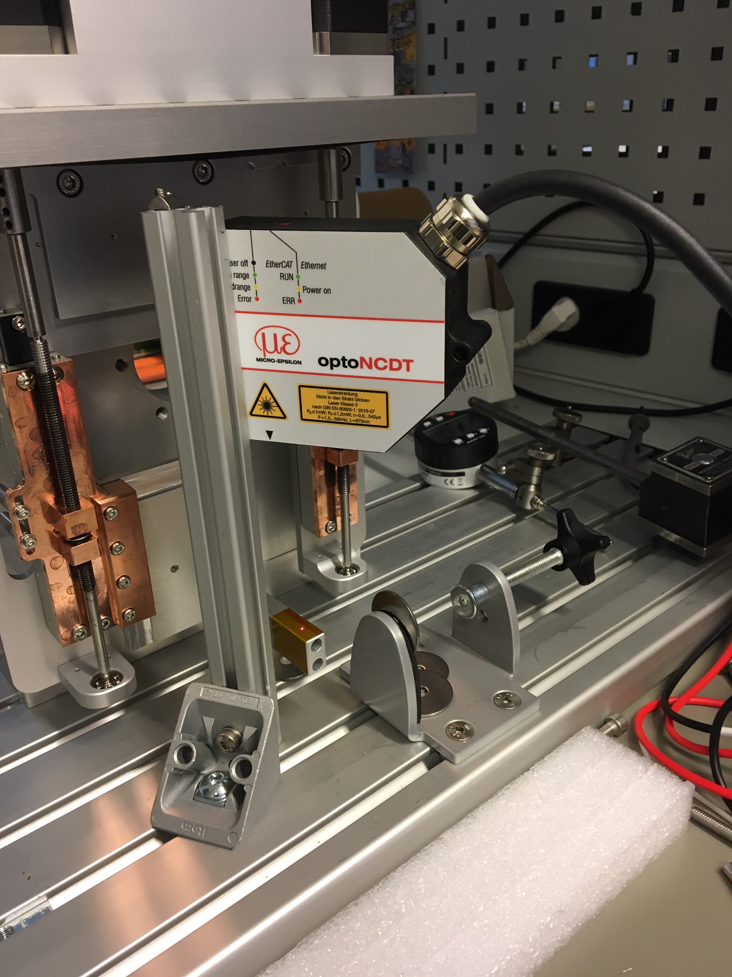

Figure 2: Test setup

## General Inspection

Inspection of all axis components from a mechanical and electrical perspective.

### Mechanical

The following checklist was followed:

* Ensure no loose components.
* Ensure no risk of collisions.
* Status of limit switches and cams
* Lemo connectors fixed

### Electrical

Mainly tests of electrical wiring:

1. Measure coil resistance of stepper motor (A and B).
2. Measure coil resistance of resolver (rotor, sin, cos).
3. Measure limit switch connections.

## Motion Tests

The motion tests have been divided into the following parts:

1. Initial motion test
2. Repeatability
3. Accuracy
4. Switch performance
5. Resolver performance

### Initial Motion Test

Motion of the whole stroke was tested with a low velocity. During this test special attention was on the following topics:

1. Noises from the equipment was observed and noted down.
2. Limit switches was tested and adjusted if needed.

As a last step, a homing sequence was performed by setting the stepper open loop counter to zero at low limit disengage flank (0 to 1).

### Repeatability

The repeatability was measured by moving to three different target positions distributed over the stroke,

1. 15mm
2. 35mm
3. 55mm

Each target position was approached 10 times from both positive and negative direction from a 2mm offset. The repeatability for each position is represented by the largest difference between the positions achieved during the test.

### Accuracy

Accuracy was measured by moving to 12 different target position distributed over the stroke starting at 5mm increasing with 5mm up to 60mm. The test was performed in both directions.

The accuracy is represented by the largest difference between target position and the actual value achieved.

### Switch Performance

The switch performance was measured by latching positions at engage/disengage of the switch. The switches were engaged and disengaged 10 times. The switch performance is represented by position range of latched position values

### Resolver Performance

The resolver performance was measured at standstill at 8 different angles of the resolver (45 degree offset). This to quantify the quality of the signal for different angles of the resolver. The resolver performance is defined as the standard deviation of 75 values at each position.

### Data Acquisition

During the motion tests (2-5) the following data was acquired:

1. ILD2300 sensor position
2. R11X-J10/N Resolver position
3. Stepper open loop counter position
4. Switch status

Data was acquired with a sampling rate of 100Hz.

## Presentation of results

The results for each axis are summarized in tables. Each test, like described above, is evaluated and the status is presented in one of the following three grades:

Table 1:Status

|  |  |  |
| --- | --- | --- |
|  | **Status** | **Description** |
| **1** | OK | Test result is fulfilling requirement. |
| **2** | Check | The test / observation needs further investigation. |
| **3** | Not OK | The test / observation is not fulfilling requirement. |

All raw data and more detailed reports can be found in the following git repository:

<https://github.com/anderssandstrom/ecmc_bifrost_slits_sat/tree/master/tests>

## Analysis

Test sequence and analysis was performed/automated by python and bash scripts. The source code can be found here:

<https://github.com/anderssandstrom/ecmccomgui/tree/master/tools>

# Results

## 11358 Axis 1

Table 2: Results 11358, axis 1

|  |  |  |  |  |
| --- | --- | --- | --- | --- |
| **General Information:** | |  |  |  |
| Serial num: | 11358 |  |  |  |
| Axis num: | 1 |  |  |  |
|  |  |  |  |  |
| **Test:** | **Description:** | **Value** | **Status:** | **Comment:** |
| **1** | **General Inspection** |  |  |  |
| **1.1** | **Mechanical** |  |  |  |
| **1.1.1** | **Observations** |  | OK |  |
| **1.2** | **Electrical** |  |  |  |
| **1.2.1** | **Observations** |  | OK |  |
| **1.2.2** | **Motor Phase A** |  | OK |  |
| **1.2.3** | **Motor Phase B** |  | OK |  |
| **1.2.4** | **Resolver Rotor** |  | OK |  |
| **1.2.5** | **Resolver Sin** |  | OK |  |
| **1.2.6** | **Resolver Cos** |  | OK |  |
| **1.2.7** | **Low Limit Switch** |  | OK |  |
| **1.2.8** | **High Limit Switch** |  | OK |  |
| **2** | **Initial Motion Test** |  |  |  |
| **2.1** | **Observations** |  | Not OK | Mechanical grinding noise when running. The noise is cyclical linked to the rotation. |
| **2.1** | **Observations** |  | OK | Limits very close to mech stops. Readjusted both to get some more margin. |
|  | **Motion Performance** | µm |  |  |
| **3** | **Repeatability** | 6,3 | OK | The repeatability is better than the accuracy of the IDL2300 sensor. Measurements with the resolver indicate that the repeatability is in the range of +- 1 micrometer |
| **4** | **Accuracy** | 42 | OK | Probably accuracy can be even higher if the scaling is tuned vs the IDL2300. Since the requirement is satisfied no further tuning was performed. |
| **5.** | **Switch Performance** | µm |  |  |
| **5.1** | **Low Limit Engage** | 40 | OK |  |
| **5.2** | **Low Limit Disengage** | *10* | OK |  |
| **5.3** | **High Limit Engage** | 10 | OK |  |
| **5.4** | **High Limit Disengage** | 20 | OK |  |
| **6** | **Resolver Performance** | 20 | OK | Variations over 1 turn |

Detailed report and raw data: <https://github.com/anderssandstrom/ecmc_bifrost_slits_sat/blob/master/tests/11358/axis1/report.md>

## 11358 Axis 2

Table 4: Results 11358, axis 2

|  |  |  |  |  |
| --- | --- | --- | --- | --- |
| **General Information:** | |  |  |  |
| Serial num: | 11358 |  |  |  |
| Axis num: | 2 |  |  |  |
|  |  |  |  |  |
| **Test:** | **Description:** | **Value** | **Status:** | **Comment:** |
| **1** | **General Inspection** |  |  |  |
| **1.1** | **Mechanical** |  |  |  |
| **1.1.1** | **Observations** |  | Check | Some Lemo nuts loose |
| **1.1.2** | **Observations** |  | Not OK | Upper limit switch lever bent (see Figure 3) |
| **1.1.3** | **Observations** |  | Not OK | Lower limit switch lever bent (see Figure 3) |
| **1.2** | **Electrical** |  |  |  |
| **1.2.1** | **Observations** |  | OK |  |
| **1.2.2** | **Motor Phase A** |  | OK |  |
| **1.2.3** | **Motor Phase B** |  | OK |  |
| **1.2.4** | **Resolver Rotor** |  | OK |  |
| **1.2.5** | **Resolver Sin** |  | OK |  |
| **1.2.6** | **Resolver Cos** |  | OK |  |
| **1.2.7** | **Low Limit Switch** |  | OK |  |
| **1.2.8** | **High Limit Switch** |  | OK |  |
| **2** | **Initial Motion Test** |  |  |  |
| **2.1** | **Observations** |  | Check | Minor scratching/grinding noise and some distinct sounds at in rotation frequency |
| **2.1** | **Observations** |  | OK | Limits very close to mech stops. Readjusted both to get some more margin. |
|  | **Motion Performance** | µm |  |  |
| **3** | **Repeatability** | 1,8 | OK | The repeatability is better than the accuracy of the IDL2300 sensor. Measurements with the resolver indicate that the repeatability is in the range of +- 1 micrometer |
| **4** | **Accuracy** | 61 | OK | Probably accuracy can be even higher if the scaling is tuned vs the IDL2300. Since the requirement is satisfied no further tuning was performed. |
| **5.** | **Switch Performance** | µm |  |  |
| **5.1** | **Low Limit Engage** | 36 | OK |  |
| **5.2** | **Low Limit Disengage** | *6* | OK |  |
| **5.3** | **High Limit Engage** | 34 | OK |  |
| **5.4** | **High Limit Disengage** | 21 | OK |  |
| **6** | **Resolver Performance** | 37 | OK | Variations over 1 turn |

Detailed report and raw data:

<https://github.com/anderssandstrom/ecmc_bifrost_slits_sat/blob/master/tests/11358/axis2/report.md>

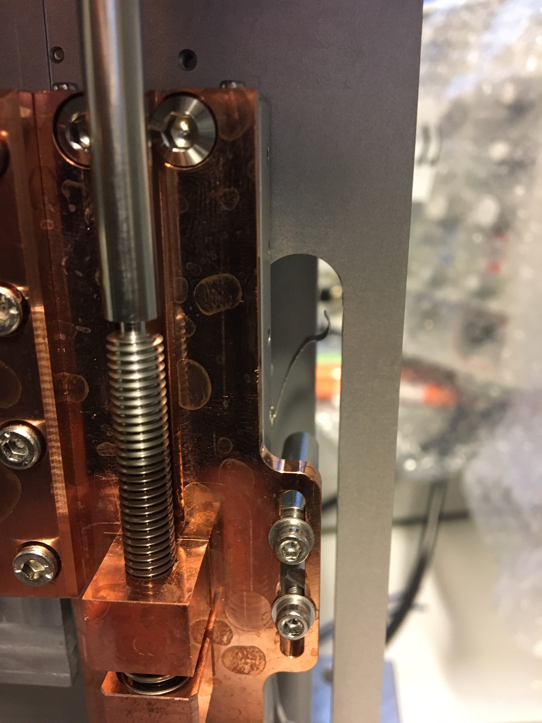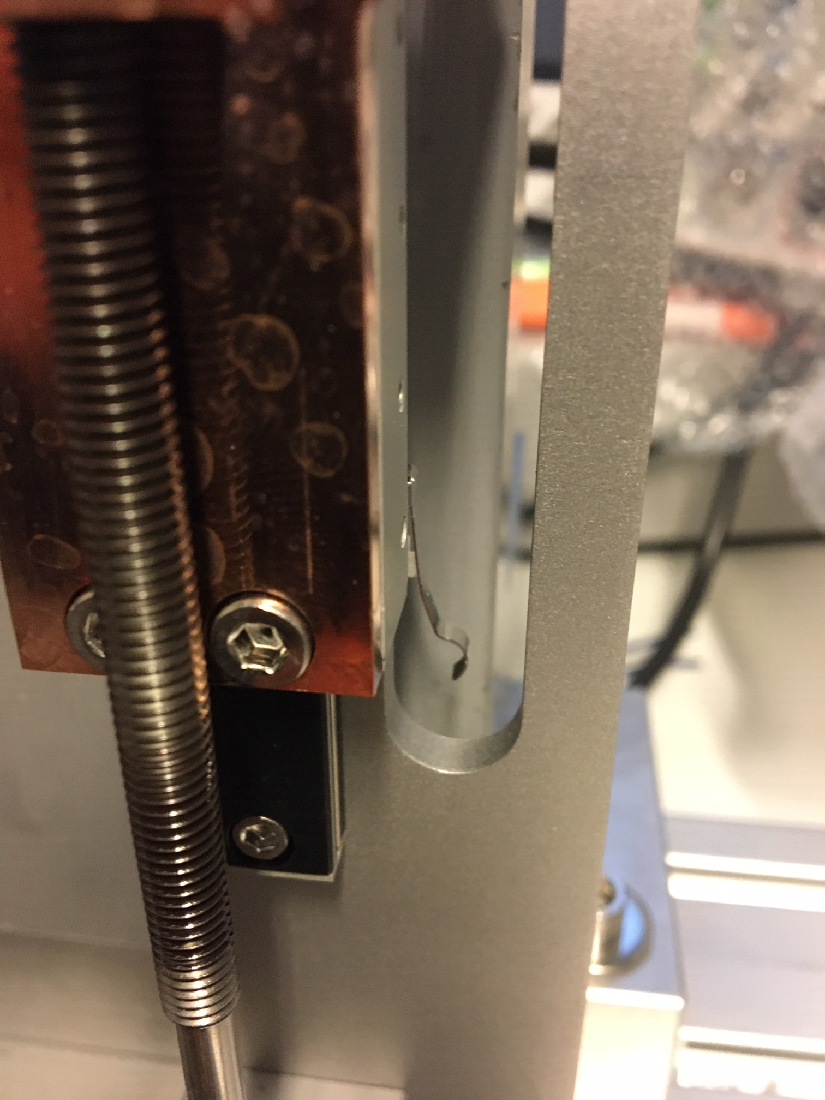

Figure 3: Bent levers of limit switches

## 11359 Axis 1

Table 5: Results 11359, axis 1

|  |  |  |  |  |
| --- | --- | --- | --- | --- |
| **General Information:** | |  |  |  |
| Serial num: | 11359 |  |  |  |
| Axis num: | 1 |  |  |  |
|  |  |  |  |  |
| **Test:** | **Description:** | **Value** | **Status:** | **Comment:** |
| **1** | **General Inspection** |  |  |  |
| **1.1** | **Mechanical** |  |  |  |
| **1.1.1** | **Observations** |  | Not OK | Lower limit switch lever bent (see Figure 4) |
| **1.2** | **Electrical** |  |  |  |
| **1.2.1** | **Observations** |  | OK |  |
| **1.2.2** | **Motor Phase A** |  | OK |  |
| **1.2.3** | **Motor Phase B** |  | OK |  |
| **1.2.4** | **Resolver Rotor** |  | OK |  |
| **1.2.5** | **Resolver Sin** |  | OK |  |
| **1.2.6** | **Resolver Cos** |  | OK |  |
| **1.2.7** | **Low Limit Switch** |  | OK |  |
| **1.2.8** | **High Limit Switch** |  | OK |  |
| **2** | **Initial Motion Test** |  |  |  |
| **2.1** | **Observations** |  | Check | Squeaking/grinding high pitch noise |
| **2.1** | **Observations** |  | OK | Limits very close to mech stops. Readjusted both to get some more margin. |
| **2.1** | **Observations** |  | Not OK | Upper limit switch is actuated very close to the "top" of the lever. The axis is almost traveling over. |
|  | **Motion Performance** | µm |  |  |
| **3** | **Repeatability** | 3 | OK | The repeatability is better than the accuracy of the IDL2300 sensor. Measurements with the resolver indicate that the repeatability is in the range of +- 1 micrometer |
| **4** | **Accuracy** | 36 | OK | Probably accuracy can be even higher if the scaling is tuned vs the IDL2300. Since the requirement is satisfied no further tuning was performed. |
| **5.** | **Switch Performance** | µm |  |  |
| **5.1** | **Low Limit Engage** | 17 | OK |  |
| **5.2** | **Low Limit Disengage** | *12* | OK |  |
| **5.3** | **High Limit Engage** | 171 | Not OK | Limit switch position vs cam wrong. Actuated with to little margin. |
| **5.4** | **High Limit Disengage** | 11 | OK |  |
| **6** | **Resolver Performance** | 37 | OK | Variations over 1 turn |

Detailed report and raw data:

<https://github.com/anderssandstrom/ecmc_bifrost_slits_sat/blob/master/tests/11359/axis1/report2.md>

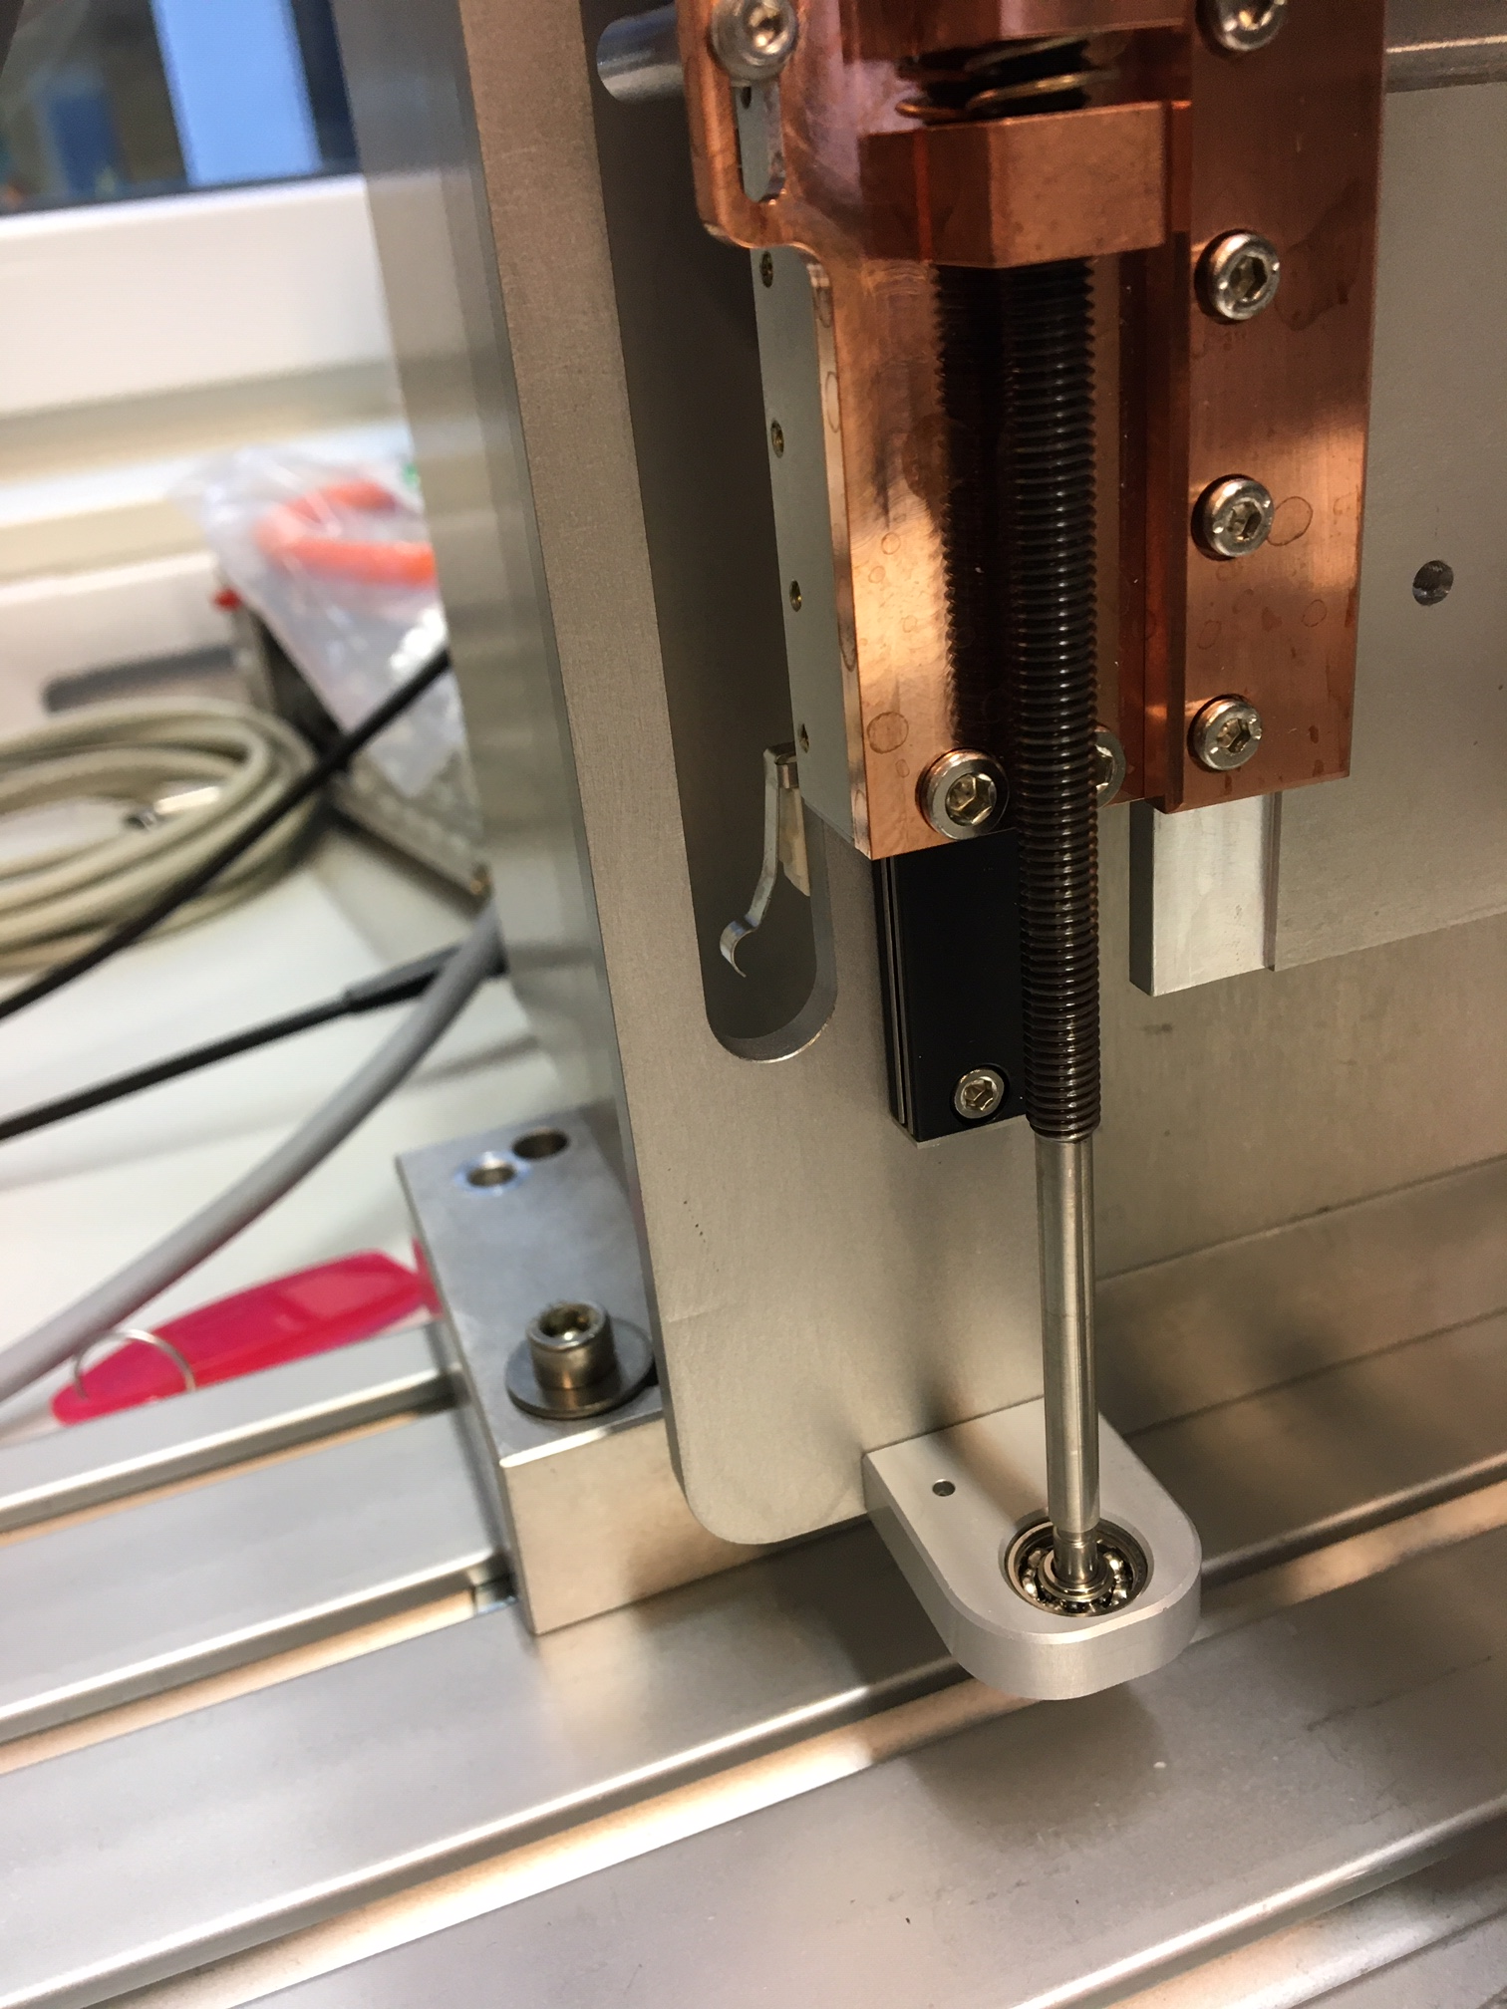

Figure 4: Bent limit switch lever

## 11359 Axis 2

Table 6: Results 11359, axis 2

|  |  |  |  |  |
| --- | --- | --- | --- | --- |
| **General Information:** | |  |  |  |
| Serial num: | 11359 |  |  |  |
| Axis num: | 2 |  |  |  |
|  |  |  |  |  |
| **Test:** | **Description:** | **Value** | **Status:** | **Comment:** |
| **1** | **General Inspection** |  |  |  |
| **1.1** | **Mechanical** |  |  |  |
| **1.1.1** | **Observations** |  | OK |  |
| **1.2** | **Electrical** |  |  |  |
| **1.2.1** | **Observations** |  | OK |  |
| **1.2.2** | **Motor Phase A** |  | OK |  |
| **1.2.3** | **Motor Phase B** |  | OK |  |
| **1.2.4** | **Resolver Rotor** |  | OK |  |
| **1.2.5** | **Resolver Sin** |  | OK |  |
| **1.2.6** | **Resolver Cos** |  | OK |  |
| **1.2.7** | **Low Limit Switch** |  | OK |  |
| **1.2.8** | **High Limit Switch** |  | OK |  |
| **2** | **Initial Motion Test** |  |  |  |
| **2.1** | **Observations** |  | Check | Low squeaking/grinding high pitch noise |
| **2.1** | **Observations** |  | OK | Limits very close to mech stops. Readjusted both to get some more margin. |
|  | **Motion Performance** | µm |  |  |
| **3** | **Repeatability** | 2 | OK | The repeatability is better than the accuracy of the IDL2300 sensor. Measurements with the resolver indicate that the repeatability is in the range of +- 1 micrometer |
| **4** | **Accuracy** | 30 | OK | Probably accuracy can be even higher if the scaling is tuned vs the IDL2300. Since the requirement is satisfied no further tuning was performed. |
| **5.** | **Switch Performance** | µm |  |  |
| **5.1** | **Low Limit Engage** | 5 | OK |  |
| **5.2** | **Low Limit Disengage** | *7* | OK |  |
| **5.3** | **High Limit Engage** | *4* | OK |  |
| **5.4** | **High Limit Disengage** | 7 | OK |  |
| **6** | **Resolver Performance** | 26 | OK | Variations over 1 turn |

Detailed report and raw data:

<https://github.com/anderssandstrom/ecmc_bifrost_slits_sat/blob/master/tests/11359/axis2/report.md>

## 11360 Axis 1

Table 7: Results 11360, axis 1

|  |  |  |  |  |
| --- | --- | --- | --- | --- |
| **General Information:** | |  |  |  |
| Serial num: | 11360 |  |  |  |
| Axis num: | 1 |  |  |  |
|  |  |  |  |  |
| **Test:** | **Description:** | **Value** | **Status:** | **Comment:** |
| **1** | **General Inspection** |  |  |  |
| **1.1** | **Mechanical** |  |  |  |
| **1.1.1** | **Observations** |  | Check | Some Lemo nuts loose |
| **1.2** | **Electrical** |  |  |  |
| **1.2.1** | **Observations** |  | OK |  |
| **1.2.2** | **Motor Phase A** |  | OK |  |
| **1.2.3** | **Motor Phase B** |  | OK |  |
| **1.2.4** | **Resolver Rotor** |  | Not OK | Pins offset one position in Lemo connector |
| **1.2.5** | **Resolver Sin** |  | Not OK | Pins offset one position in Lemo connector |
| **1.2.6** | **Resolver Cos** |  | Not OK | Pins offset one position in Lemo connector |
| **1.2.7** | **Low Limit Switch** |  | OK |  |
| **1.2.8** | **High Limit Switch** |  | OK |  |
| **2** | **Initial Motion Test** |  |  |  |
| **2.1** | **Observations** |  |  |  |
| **2.1** | **Observations** |  |  |  |
|  | **Motion Performance** |  |  |  |
| **3** | **Repeatability** |  |  |  |
| **4** | **Accuracy** |  |  |  |
| **5.** | **Switch Performance** |  |  |  |
| **5.1** | **Low Limit Engage** |  |  |  |
| **5.2** | **Low Limit Disengage** |  |  |  |
| **5.3** | **High Limit Engage** |  |  |  |
| **5.4** | **High Limit Disengage** |  |  |  |
| **6** | **Resolver Performance** |  |  |  |

Rewiring needed. It seems to involve major mechanical disassembly to rewire the Lemo connectors. Therefore, no motion tests performed for this axis.

## 11360 Axis 2

Table 8: Results 11360, axis 2

|  |  |  |  |  |
| --- | --- | --- | --- | --- |
| **General Information:** | |  |  |  |
| Serial num: | 11360 |  |  |  |
| Axis num: | 2 |  |  |  |
|  |  |  |  |  |
| **Test:** | **Description:** | **Value** | **Status:** | **Comment:** |
| **1** | **General Inspection** |  |  |  |
| **1.1** | **Mechanical** |  |  |  |
| **1.1.1** | **Observations** |  | Check | Some Lemo nuts loose |
| **1.2** | **Electrical** |  |  |  |
| **1.2.1** | **Observations** |  | OK |  |
| **1.2.2** | **Motor Phase A** |  | OK |  |
| **1.2.3** | **Motor Phase B** |  | OK |  |
| **1.2.4** | **Resolver Rotor** |  | Not OK | Pins offset one position in Lemo connector |
| **1.2.5** | **Resolver Sin** |  | Not OK | Pins offset one position in Lemo connector |
| **1.2.6** | **Resolver Cos** |  | Not OK | Pins offset one position in Lemo connector |
| **1.2.7** | **Low Limit Switch** |  | OK |  |
| **1.2.8** | **High Limit Switch** |  | OK |  |
| **2** | **Initial Motion Test** |  |  |  |
| **2.1** | **Observations** |  |  |  |
| **2.1** | **Observations** |  |  |  |
|  | **Motion Performance** |  |  |  |
| **3** | **Repeatability** |  |  |  |
| **4** | **Accuracy** |  |  |  |
| **5.** | **Switch Performance** |  |  |  |
| **5.1** | **Low Limit Engage** |  |  |  |
| **5.2** | **Low Limit Disengage** |  |  |  |
| **5.3** | **High Limit Engage** |  |  |  |
| **5.4** | **High Limit Disengage** |  |  |  |
| **6** | **Resolver Performance** |  |  |  |

Rewiring needed. It seems to involve major mechanical disassembly to rewire the Lemo connectors. Therefore, no motion tests performed for this axis.

## 11361 Axis 1

Table 9: Results 11361, axis 1

|  |  |  |  |  |
| --- | --- | --- | --- | --- |
| **General Information:** | |  |  |  |
| Serial num: | 11361 |  |  |  |
| Axis num: | 1 |  |  |  |
|  |  |  |  |  |
| **Test:** | **Description:** | **Value** | **Status:** | **Comment:** |
| **1** | **General Inspection** |  |  |  |
| **1.1** | **Mechanical** |  |  |  |
| **1.1.1** | **Observations** |  | OK |  |
| **1.2** | **Electrical** |  |  |  |
| **1.2.1** | **Observations** |  | OK |  |
| **1.2.2** | **Motor Phase A** |  | OK |  |
| **1.2.3** | **Motor Phase B** |  | OK |  |
| **1.2.4** | **Resolver Rotor** |  | OK |  |
| **1.2.5** | **Resolver Sin** |  | OK |  |
| **1.2.6** | **Resolver Cos** |  | OK |  |
| **1.2.7** | **Low Limit Switch** |  | OK |  |
| **1.2.8** | **High Limit Switch** |  | OK |  |
| **2** | **Initial Motion Test** |  |  |  |
| **2.1** | **Observations** |  | OK | Limits very close to mech stops. Readjusted both to get some more margin. |
|  | **Motion Performance** | µm |  |  |
| **3** | **Repeatability** | 5 | OK | The repeatability is better than the accuracy of the IDL2300 sensor. Measurements with the resolver indicate that the repeatability is in the range of +- 1 micrometer |
| **4** | **Accuracy** | 30 | OK | Probably accuracy can be even higher if the scaling is tuned vs the IDL2300. Since the requirement is satisfied no further tuning was performed. |
| **5.** | **Switch Performance** | µm |  |  |
| **5.1** | **Low Limit Engage** | 6 | OK |  |
| **5.2** | **Low Limit Disengage** | *2* | OK |  |
| **5.3** | **High Limit Engage** | *19* | OK |  |
| **5.4** | **High Limit Disengage** | 11 | OK |  |
| **6** | **Resolver Performance** | 3 | OK | Variations over 1 turn |

Detailed report and raw data:

<https://github.com/anderssandstrom/ecmc_bifrost_slits_sat/blob/master/tests/11361/axis1/report.md>

## 11361 Axis 2

Table 10: Results 11361, axis 2

|  |  |  |  |  |
| --- | --- | --- | --- | --- |
| **General Information:** | |  |  |  |
| Serial num: | 11361 |  |  |  |
| Axis num: | 2 |  |  |  |
|  |  |  |  |  |
| **Test:** | **Description:** | **Value** | **Status:** | **Comment:** |
| **1** | **General Inspection** |  |  |  |
| **1.1** | **Mechanical** |  |  |  |
| **1.1.1** | **Observations** |  | OK |  |
| **1.2** | **Electrical** |  |  |  |
| **1.2.1** | **Observations** |  | OK |  |
| **1.2.2** | **Motor Phase A** |  | OK |  |
| **1.2.3** | **Motor Phase B** |  | OK |  |
| **1.2.4** | **Resolver Rotor** |  | OK |  |
| **1.2.5** | **Resolver Sin** |  | OK |  |
| **1.2.6** | **Resolver Cos** |  | OK |  |
| **1.2.7** | **Low Limit Switch** |  | OK |  |
| **1.2.8** | **High Limit Switch** |  | OK |  |
| **2** | **Initial Motion Test** |  |  |  |
| **2.1** | **Observations** |  | OK | Limits very close to mech stops. Readjusted both to get some more margin. |
|  | **Motion Performance** | µm |  |  |
| **3** | **Repeatability** | 3 | OK | The repeatability is better than the accuracy of the IDL2300 sensor. Measurements with the resolver indicate that the repeatability is in the range of +- 1 micrometer |
| **4** | **Accuracy** | 36 | OK | Probably accuracy can be even higher if the scaling is tuned vs the IDL2300. Since the requirement is satisfied no further tuning was performed. |
| **5.** | **Switch Performance** | µm |  |  |
| **5.1** | **Low Limit Engage** | 21 | OK |  |
| **5.2** | **Low Limit Disengage** | *4* | OK |  |
| **5.3** | **High Limit Engage** | *21* | OK |  |
| **5.4** | **High Limit Disengage** | 7 | OK |  |
| **6** | **Resolver Performance** | 30 | OK | Variations over 1 turn |

Detailed report and raw data:

<https://github.com/anderssandstrom/ecmc_bifrost_slits_sat/blob/master/tests/11361/axis2/report.md>

# CONCLUSIONS

The results presented in chapter 5 can be summarized as follows:

* Most requirements have been met.
* Limit switches:
  + Some of the levers have been bent. This makes it hard for maintenance to replace and is also hard to ensure a proper engaging/disengaging process.
  + At least one limit switch was found to be too far from the cam, resulting in unreliable engaging/disengaging and risk of passing the switch without actuation.
* Noise:
  + There was mechanical noise from some of the axes. Our conclusion is that the noise is not from the motors but from other component like seals, bearings or lead screw.
  + All the different axes sounded different.
* Electrical:
  + Some of the Lemo connectors were not tightened properly (loose nuts).
  + The resolver was connected to the wrong pins in the Lemo connector for both axes of the 11360 unit. It seems hard to access the Lemo connector without a major disassembly so no motion tests were performed on this unit.

# references

1. EtherCAT organization, <https://www.ethercat.org>
2. ecmc, open source motion control, <https://accelconf.web.cern.ch/icalepcs2017/talks/mocpl05_talk.pdf>
3. Control system configurations and raw data, <https://github.com/anderssandstrom/ecmc_bifrost_slits_sat/>
4. EL7037, <https://www.beckhoff.com/english.asp?ethercat/el7037.htm>
5. EL1808, <https://www.beckhoff.com/english.asp?ethercat/el1808.htm>
6. EL2808, <https://www.beckhoff.com/english.asp?ethercat/el2808.htm>
7. EL7201, <https://www.beckhoff.com/english.asp?ethercat/el7201.htm>
8. AML 42.3 Stepper motor, <https://arunmicro.com/products/D42-3_UHV_Compatible_Stepper_Motor/>
9. Micro-Epsilon laser triangulation sensor, <https://www.micro-epsilon.com/displacement-position-sensors/laser-sensor/optoNCDT_2300_basic/>
10. AMCI r11 Resolver, <https://www.amci.com/plc-automation-products/r11-size-11-brushless-resolver-sensors>
11. Bifrost Divergence Slits DTU Physics Test Plan 18032, Revision 4 of Oct 27th, 2020

Document Revision history

| Revision | Reason for and description of change | Author | Date |
| --- | --- | --- | --- |
| 1 | First issue | Anders Sandström | 2020-12-17 |
|  |  |  |  |
|  |  |  |  |

# Appendix A Micro Epsilon ILD2300 Calibration REPORT

